**Bharavi**

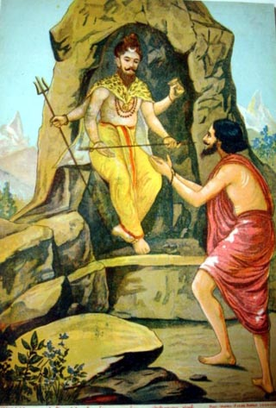

Bharavi was a great Sanskrit poet who wrote one of the greatest classical Sanskrit epics that was hailed as Mahakavya or great poetry. His epic was called Kiratarjuniya or Arjuna and the mountain man. This epic talks of the great warrior Arjuna and his battle with a savage mountain man, who then turns out to be Lord Shiva. There are many interesting facts about Bharavi's life history. Though no such biography of Bharavi exists, yet we find valuable information about this great poet in his works. Intricate styles and very superior forms of expression characterized his style of poetry. There is a chance that he may have influenced the 8th Century poet Magha. It is estimated that Bharavi came from the South of India. He is said to have flourished during the empire of King Durvinita and King Simhavishnu of the Pallavan dynasty, which was a major empire and widespread in the south of India.

**Personal Life**  
There is a famous story related to Bharavi. It is said that Bharavi was recognized as genius by everyone around him since he was in his young age. Everyone used to love and admire his poems and writing, he was an inspiration for many but this did not satisfy Bharavi. This strong characterstic may have come in Bharavi from the absence of his father's acknowledgement and admiration of him or his work. His father never felt the need to praise Bharavi, which thoroughly disappointed him. He constantly tried to gather his father's appreciation and acknowledgement but he always failed in doing so. Since Bharavi never got any encouragement by his father, his disappointment soon turned into anguish. All the passive emotions in his started to take the form of rage and he felt the need to take revenge from his father for his indifferent attitude towards him. He went too far with this revenge thing and decided that nothing could be equivalent to whant his father has made me feel like for all these years when he yearned for his appreciation and decided that e wanted to kill his father. He saw his father and mother sitting comfortably together and in a deep conversation. He slowly moved towards his father with a sword in his hand. As he lifted the sword to attack his father, the sword struck a tile on the ceiling. Something fell on the head of Bharavi and he picked it up to see, to his surprise it was a torn piece of a manuscript. He read it to see what was written on it. It was written that before doing something, one should think a thousand times. And then he paid attention to what his father and mother were conversing about. His mother was asking his father why he never appreciates and encourages Bharavi. To this his father replied that he knows very well that Bharavi is a poetic genius and he also knew that he was capable of much more than he has already achieved. His father thought that if he would praise him then Bharavi would not feel the need to do more things and achieve greater heights and he did not want to see his son resting just now. He thought that his not appreciating Bharavi will turn out to be a good thing in Bharavi's life eventually. After hearing this, Bharavi felt ashamed of himself for he was about to do a heinous crime. He could not believe that he ahd been so upset and disappointed that his heart got filled with vengeance. He confessed all these feelings in front of his father and begged for his forgiveness and he understood for the rest of his lifetime that sometimes it is important to withhold appreciation to inspire someone to do better than his achievements.

**Major Work**

Kiratarjuniya is considered as his only work but his was a magnanimous contribution to the world of Sanskrit literature. It is a poem written in 18 cantos. A.K. Warder, an Indologist, thinks of Kiratarjuniya as the perfect epic poem in the history of any literature. He thought that more and more intricacy was put into the expression of the poem and every detail in the poem was beautifully polished. Bharavi used the most difficult words of Sanskrit language and fine nuances of Sanskrit grammar. Even after putting in such complicated and fine details in the poem, Bharavi achieved commendable directness and conciseness. In Sanskrit language, Bharavi is known for his epic weight of meaning in his work, just like Kalidasa was famous for his similes and Dandin was popular for his wordplay. It is said that Dandin's great grandfather was a friend of Bharavi as king Visnuvardhana brought them together. There was a famous commentator who was called Mallinatha, he considered Bharavi's words very hard to understand and decipher.